Assignment

by

B20MT005 and M21AIE208

**Assignment Logistics**

1. The assignment is done using **python 3.8**
2. Dataset used is Euro/INR exchange rate and gathered from RBI website

<https://dbie.rbi.org.in/BOE/OpenDocument/1608101729/OpenDocument/opendoc/openDocument.faces?logonSuccessful=true&shareId=0>

1. We will be analysis daily timeframe data from period **1st Jan 2022** till **1st Jan 2023** that has 176 datapoints

**Part 1**

ARMA/ ARIMA and its variation

**Step 1: Loading the data**

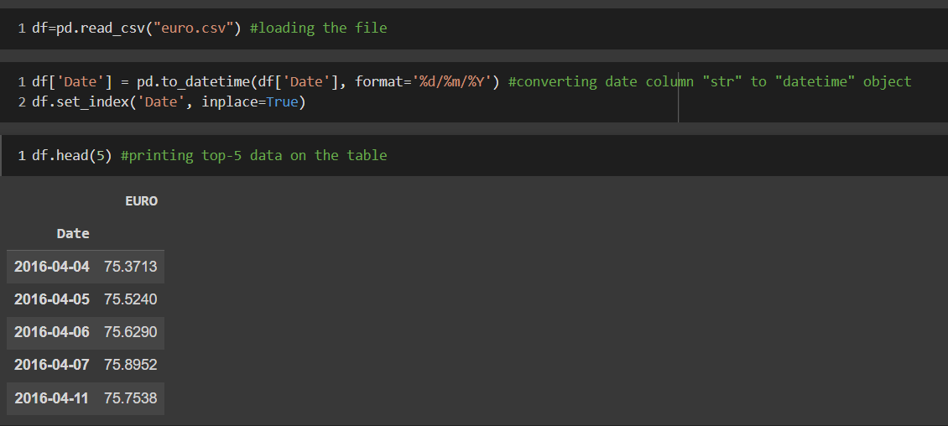

**Step 2: Printing Basic Statistics**

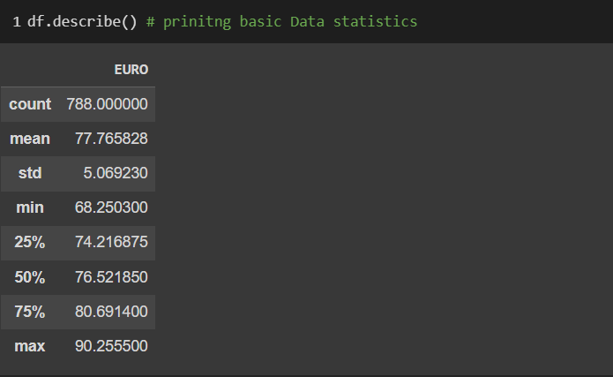

**Step 3: Plotting time series**

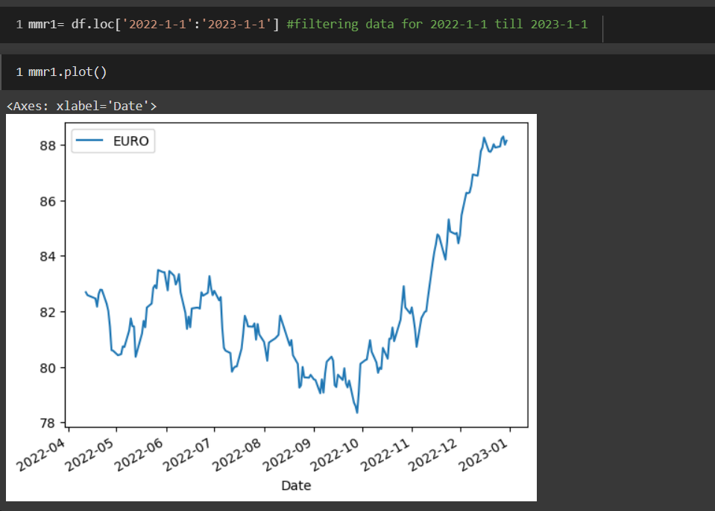

**Step 4: Test for non-stationarity using ADF and PP**

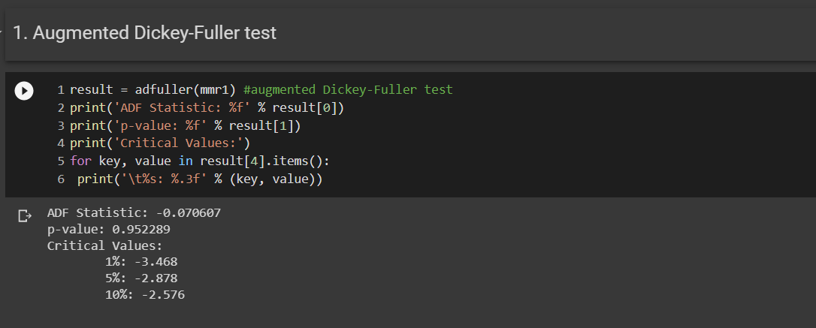

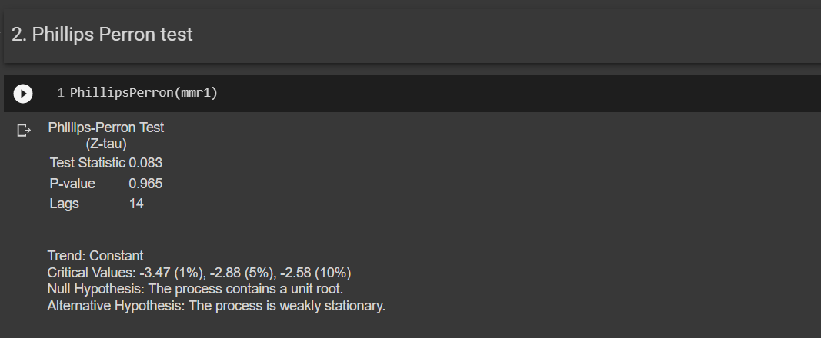

ADF and PP statistics and p-value rejects the null hypothesis for stationarity, hence this series is non-stationary

**Step 5: Test for non-stationarity at First Difference of the series using Autocorrelation and Partial Auto Correlation**

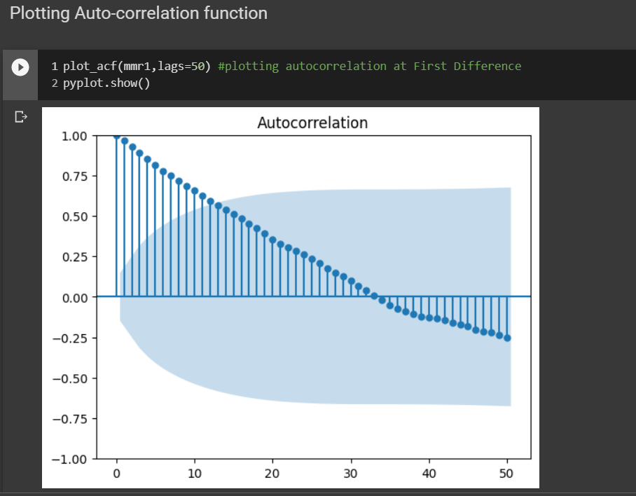

Figure Autocorrelation plot of actual series with lag 50

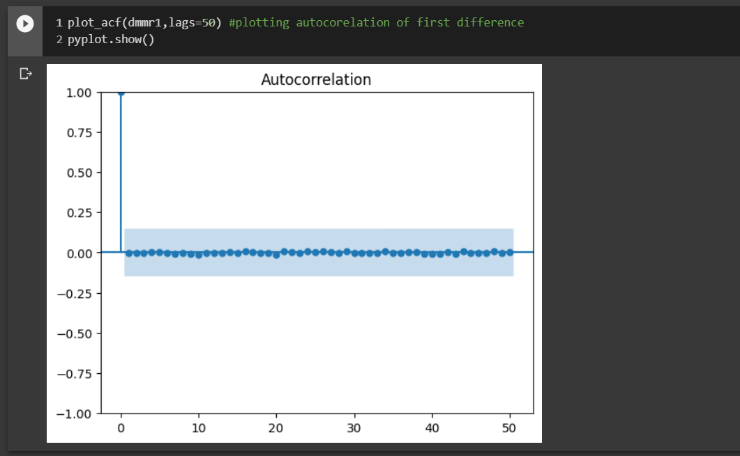

Figure Autocorrelation of First Difference

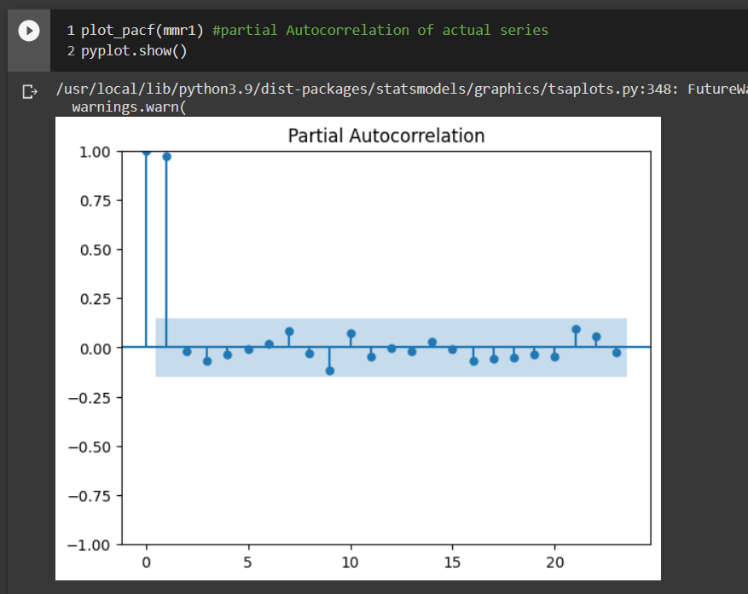

Figure Partial Autocorrelation of the Actual Series

Since ACF plot shows that Auto-correlation is dropping immediately after first lag and we can use ARIMA model

**Step 5: Building ARIMA model**

1. **ARIMA model [Order (5,0,1)]**

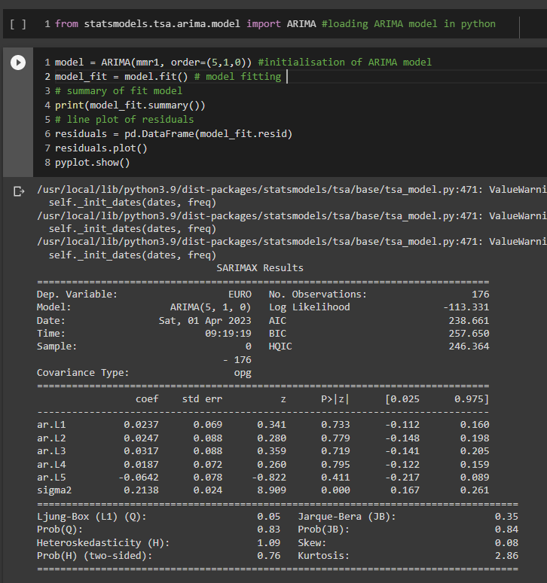

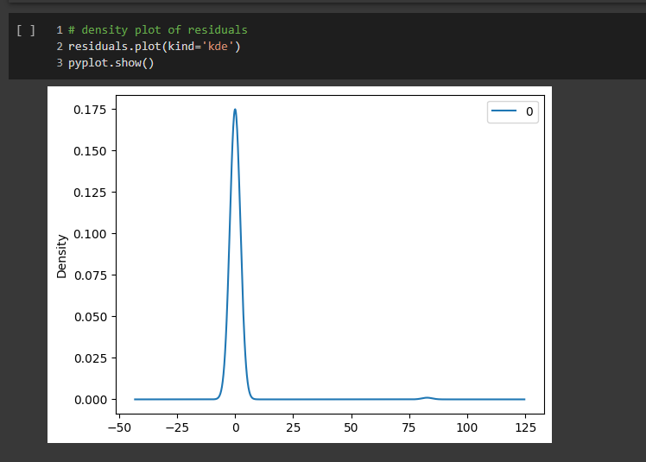

Figure Density plots for Residuals

**Step 6: Checking the plot of the forecast and the actual time series**

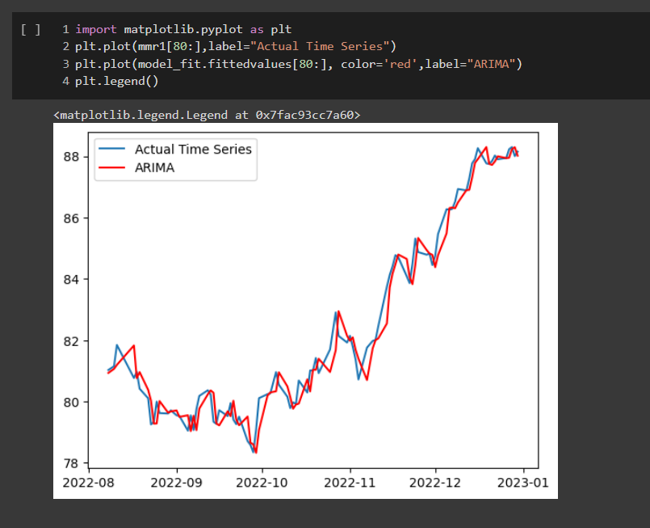

**Step 7: Building 2 different ARIMA model**

1. **ARIMA [Order(5,0,1)]**
2. **ARIMA [Order(10,0,1)]**

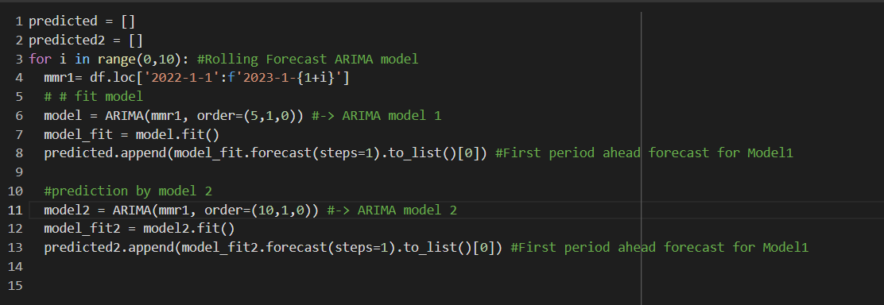

We are predicting the first period ahead forecast for 10 points i.e **2nd Jan 2023** till **11th Jan 2023**

**Predicted Results from 2 forecasters**

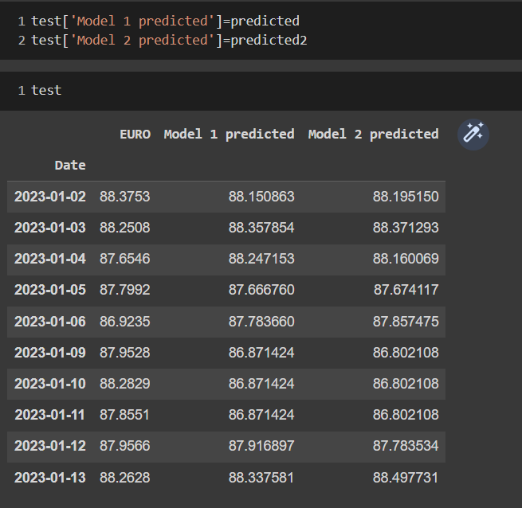

**Step 8: Evaluating Model 1 and Model 2 with MSPE and Debol Mariano Test**

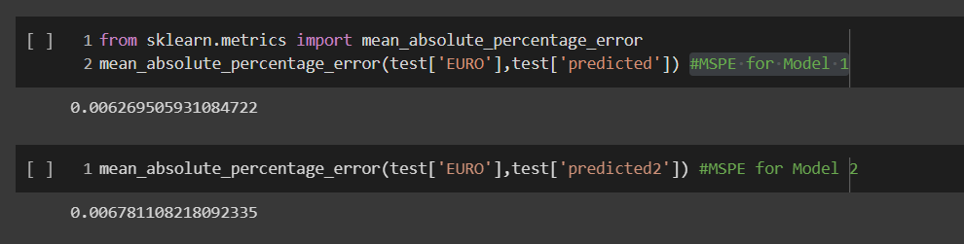

Figure 5 MSPE calculation for Model1 and Model2

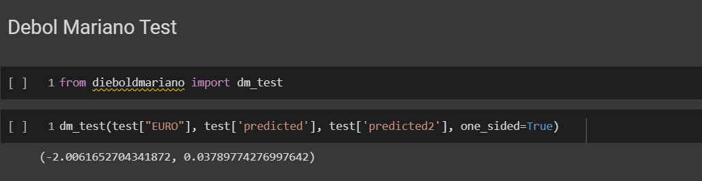

Figure 6 Forecaster comparison using Debold Mariano Test

|  |  |  |
| --- | --- | --- |
| **Model** | **Order** | **MSPE** |
| ARIMA model 1 | [5,0,1] | 0.0062 |
| ARIMA model 2 | [10,0,1] | 0.0067 |

Since we can reject the null hypothesis of Debold Mariano test at 3% which suggest both forecaster are similar and MSPE show **model 1 is performing better**.

**Step 9: Exchange Forecast for next 10 days using ARIMA model 1**

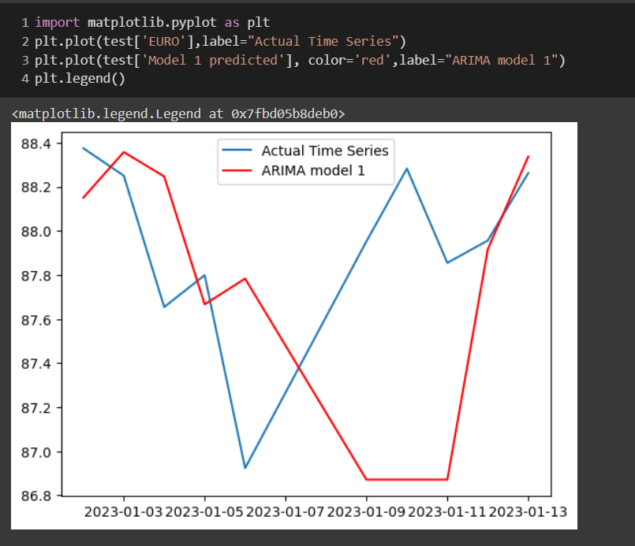

Figure 7 Prediction for next 10 days Exchange rate [EURO]

**Part 2**

ARCH/ GARCH and its variation

Stationarity of the data is already checked in Step1 till Step4

**Step 5: Building 2 different ARCH model**

1. ARCH model with lag 5
2. ARCH model with lag 10

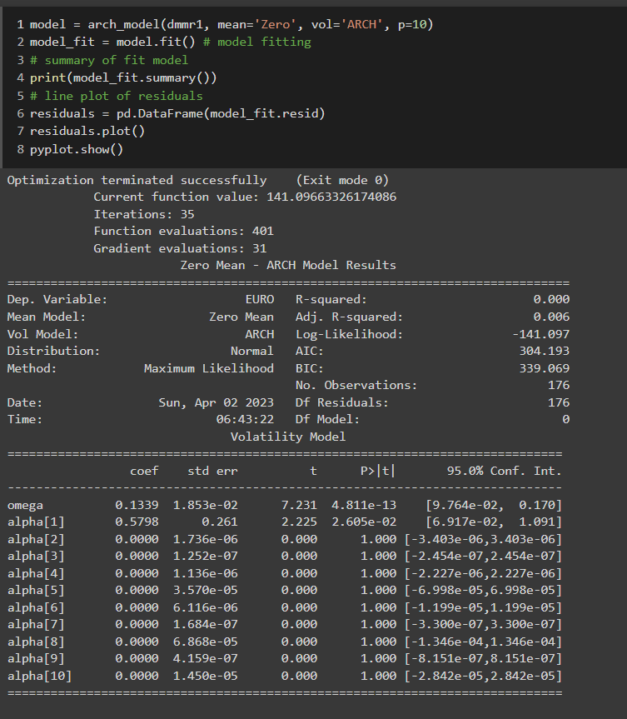

Figure 8 ARCH model fit with lag 5

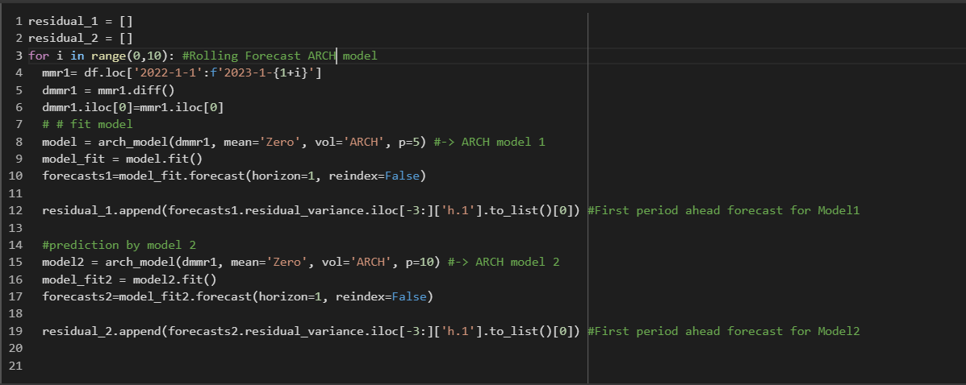

Predicted Results from both models ARCH model 1 and ARCH model 2

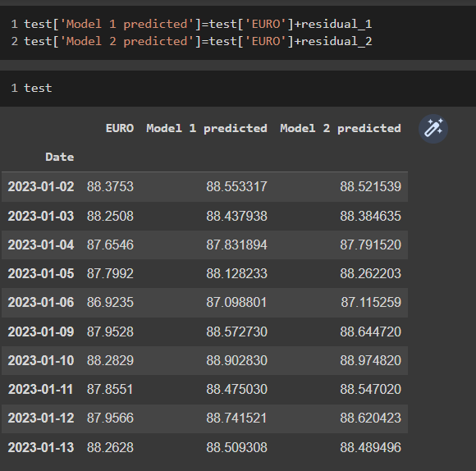

**Step 6: Evaluating Model 1 and Model 2 with MSPE and Debol Mariano Test**

**MSPE**

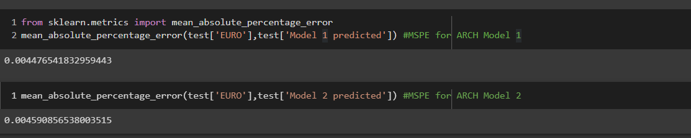

**Debold Mariano Test**

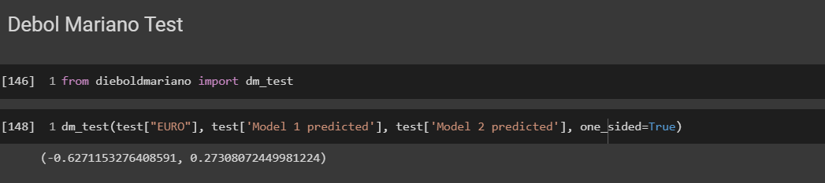

|  |  |  |
| --- | --- | --- |
| **Model** | **Lag** | **MSPE** |
| ARCH model 1 | 5 | 0.0044 |
| ARCH model 2 | 10 | 0.0045 |

**Step 7: Exchange Forecast for next 10 days using ARCH model 1**

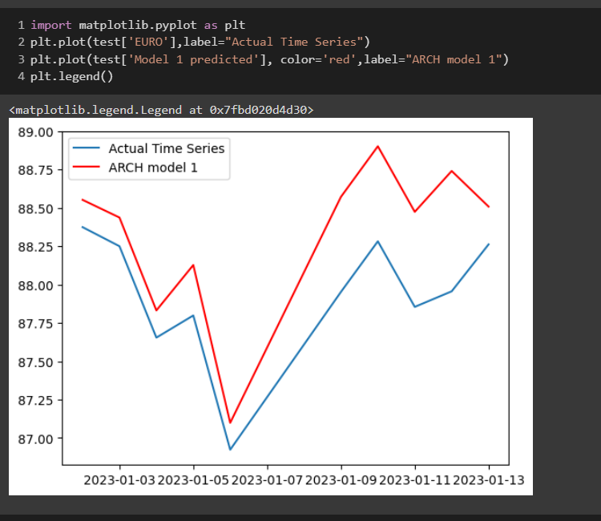

**Comparing ARIMA and ARCH model**

|  |  |
| --- | --- |
| **Model** | **MSPE** |
| ARIMA model 1 | 0.0062 |
| ARIMA model 2 | 0.0067 |
| ARCH model 1 | 0.0044 |
| ARCH model 2 | 0.0045 |

**Conclusion:** ARCH model have better forecast accuracy than ARIMA models